Press release 22 July, 2020

**Interim report January – March 2020**

MSAB – Increase in sales and profit

**January - June**

* Net sales increased 15.1 percent to SEK 150.1 (130.4) million (13.4 percent in local currencies).
* EBIT amounted to SEK 3.3 (-17.1) million.
* The EBIT margin was 2.2 (-13.1) percent.
* Profit after tax amounted to SEK 1.9 (-15.3) million.
* Earnings per share amounted to SEK 0.10 (-0.82).
* Cash flow from operating activities amounted to SEK 7.8 (3.9) million.
* Cash and cash equivalents and short-term investments at the end of the period amounted to SEK 64.8 (52.5) million.

**Second quarter**

* Net sales increased 30 percent to SEK 83.9 (64.1) million (30.3 percent in local currencies).
* EBIT amounted to SEK 12.1 (-11.4) million.
* The EBIT margin was 14.4 (-17.8) percent.
* Profit after tax amounted to SEK 10.4 (-10.8) million.
* Earnings per share amounted to SEK 0.56 (-0.58).
* Cash flow from operating activities amounted to SEK -1.6 (0.7) million.

**MSAB in brief**

MSAB is a world leader in mobile forensics technology with the aim of extracting and analysing data from confiscated mobile devices, mainly from mobile phones. The Company has its own sales offices and sales representatives in Europe, North America, South America, China, Australia, Singapore, Japan and Russia, and together with a number of distributors, covers most of the world. The proprietary products have become a de facto standard in the field and are used for securing evidence in more than 100 countries. These products are complemented by a wide range of training courses with the possibility of becoming certified in a forensically sound methodology. Customers are primarily law enforcement agencies, such as police, military and customs. MSAB is listed on NASDAQ Stockholm under the ticker symbol: MSAB B.

Comments from the CEO

In early April, the situation for Sweden and the world was more uncertain than ever, and the global community had shut down in a way that has never before been witnessed. Covid-19 was spreading from country to country, region by region. Our customers stopped receiving visitors and we were unable to travel at all. The uncertainty surrounding this second quarter is greater than anything I have ever experienced as MSAB’s CEO.

My message to the organisation was crystal clear: we are facing one of the greatest challenges of our time and we have two choices. Either we tighten our belts and survive on hope, or we accept the challenge and adapt to the new conditions with a view to the possibilities. My choice was to accept the challenge and see the possibilities in the current situation.

MSAB has been operating for 36 years – through good times and bad – taking on challenges as they appear and adapting. And this time is no different.

One of the most important decisions we took was to not cancel a single meeting or activity, but rather to adapt. We transformed all planned customer interactions and exhibitions to their digital equivalents. We have had a record-breaking number of customer interactions during the second quarter and we have done so successfully.

The current situation has hastened our and our customers’ digital transformation. This has provided us with new insights which will impact our own and our customers’ ways of working forever.

Considering the prevailing conditions at the beginning of the second quarter, it is with considerable pride that I report that we grew 30 percent, with all-time highs for the second quarter for both sales and profit.

Growth for the period January – June was broad. New sales and license renewal sales both increased compared to last year. The increasing number of license renewals demonstrates once again how much users value the benefits our products provide, not just for our customers, but for the greater legal security of society in general. Furthermore, it also clearly demonstrates the strength of our business model.

Once again, XRY Office represents the lion’s share of new sales. We have been developing the product for 18 years and now – because of the continual improvements – it is better than ever. XRY Office supports the most relevant phones and apps that our customers deal with. Today, XRY Office supports over 32,000 different device profiles!

Training was one area that demonstrated somewhat negative growth during the period. This is a direct consequence of not being able to travel to meet our customers. We have rapidly increased the pace at which we are digitalising an ever-increasing number of our courses for on-line study. There are several reasons why this takes time, and some training is difficult to execute completely in digital format.

It is difficult to assess with any certainty how the global pandemic will affect us and our customers in the future. But one thing is certain: the future will look different for both MSAB and our customers.

The need to secure evidence retrieved from digital devices will continue to be a high priority for our customers. We will continue to deliver the most effective solutions on the market. Exactly how we do this in the best possible manner will depend on our own strategy and how the world at large looks.

One thing is certain, MSAB is committed to its ambition to be the best in the world at providing value for customers – no matter what conditions arise.

Enjoy your summer!

Stockholm, July 2020

Joel Bollö  
Chief Executive Officer

Comments on operations

The market  
EMEA & Latin America – experienced most growth during the period. We continue to deliver value to our customers, and with our focus on customer benefit we demonstrate that we understand our customers’ needs. EMEA demonstrated strong growth for the first half-year.

North America – sales for the region grew somewhat compared with last year. Our largest customers in North America are federal authorities, all of which have budget years ending 30 September.

Asia and Commonwealth of Independent States (CIS) – within the region, southeast Asia demonstrated good growth. Our offering to countries in the region was further strengthened through expansion in our regional presence.

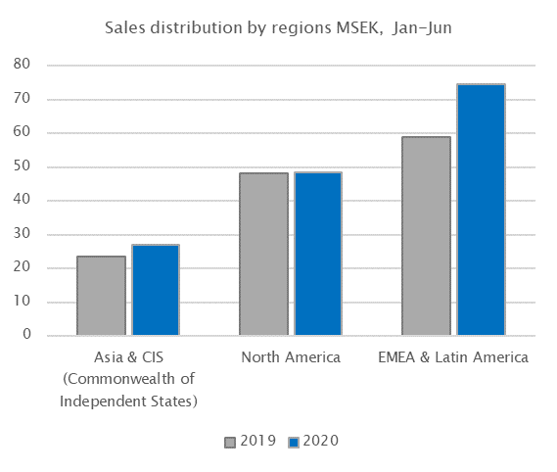

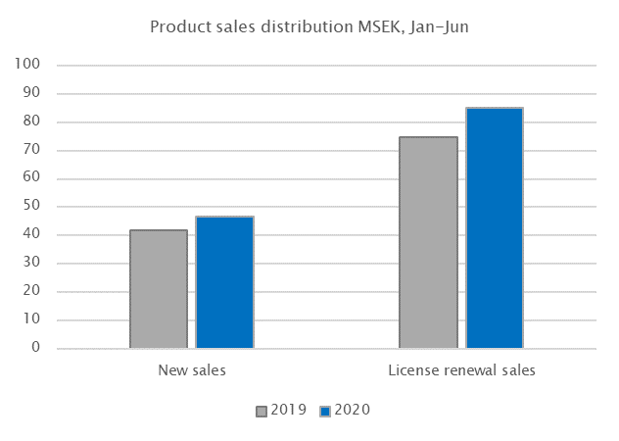

Products

Development has been working hard to add value to our product offering, and during the period we started delivering the latest version of XRY Kiosk. This latest model has been completely redesigned and its reception on the market has been phenomenal. The current version of Kiosk is probably the best in the world as regards design and function. The basic unit is new, with a larger screen, faster retrieval, a step-by-step user interface, and many other new improvements.

XRY Office was also updated during the period. Some of the most powerful additions to Office include Photon support for the most advanced apps, expanded support for iPhone, unique support for Huawei and improvements for Samsung. In total, we now have support for over 32,000 different profiles, which is an increase of more than 5,000 in one year, or 22 new profiles for each workday over the last twelve months.

Training

Revenue from training activities declined somewhat compared with the previous year, which is a direct consequence of travel restrictions during the pandemic. Because of the prevailing situation, we have increased the pace at which we are vitalising our training operations, an exercise which was already underway. Demand for our best accredited courses is strong, so we will continue to lay focus on our training offering.

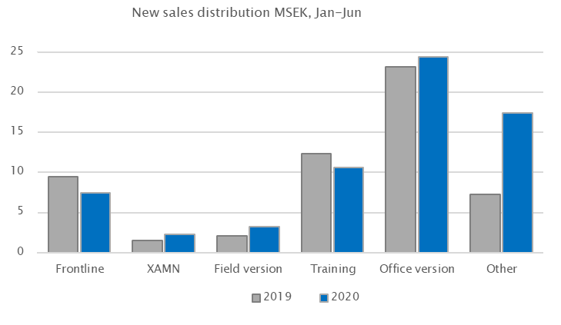

|  |  |
| --- | --- |
|  |  |

Comments on financial performance

Net sales

Consolidated net sales rose 30.8 percent during the second quarter to SEK 83.9 (64.1) million, and for the period sales rose 15.1 percent to SEK 150.1 (130.4) million. In local currencies, net sales increased 13.4 percent for the quarter and 30.3 percent for the period. Please refer to the section *Comments on operations* and the associated graphs for more detailed information on income.

Expenses

Expenses for goods for resale for the quarter amounted to SEK 8.3 (4.0) million and for the period SEK 13.4 (9.9) million. Direct expenses are linked to the product mix sold. Other external expenses included depreciation amounting to SEK 14.4 (22.8) million for the quarter and SEK 34.5 (43.9) million for the period. Personnel expenses amounted to SEK 49.1 (48.7) million for the quarter and SEK 98.9 (93.7) million for the period.

Profit/loss

EBIT for the quarter amounted to SEK 12.1 (-11.4) million, corresponding to an EBIT margin of 14.4 (-17.8) percent. EBIT for the period amounted to SEK 3.3 (-17.1) million, corresponding to an EBIT margin of 2.2 (-13.1) percent. The net financial income/expense was SEK -0.9 (1.1) million for the quarter and SEK -0.1 (2.6) million for the period. Net financial income/expense stemmed primarily from revaluation of cash and cash equivalents in foreign currencies. Profit after tax amounted to SEK 10.4 (-10.8) million for the quarter and SEK 1.9 (15.3) million for the period.

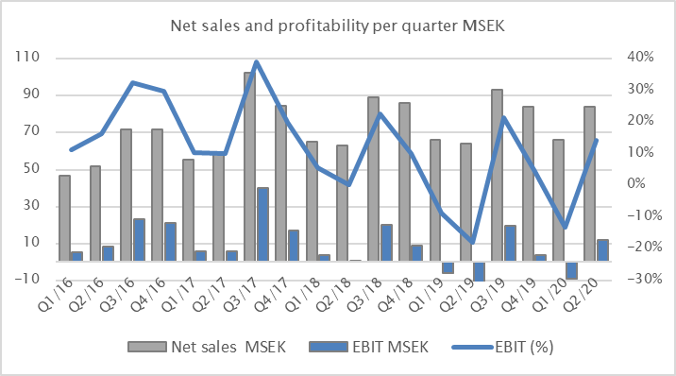

Cash flow and financial position

The equity/assets ratio at the end of the period was 41.2 (33.7) percent. Cash flow from operating activities for the quarter amounted to SEK -1.6 (3.9) million and to SEK 7.8 (0.2) million for the period. No dividends were distributed (SEK 40.6 million) during the quarter, as a precautionary response to the pandemic. Cash and cash equivalents at the end of the period amounted to SEK 64.8 (52.5) million.

Fluctuations in quarterly sales and profit

Consolidated sales and profit both tend to fluctuate between quarters, primarily due to our customers’ purchasing patterns and single, larger orders. This is illustrated in the diagram below, where the substantial variation between individual quarters is clearly visible for sales and profit. Viewed over a one-year period, the trend is more even and stable for sales and profit. However, even when trends are viewed across one-year periods, growth has occurred in waves, where for example growth was strong in 2015, more modest in 2016, and then significantly stronger in 2017.

Personnel

There were 204 (185) employees in the Group at the end of the period. The average number of employees was 203 (182).

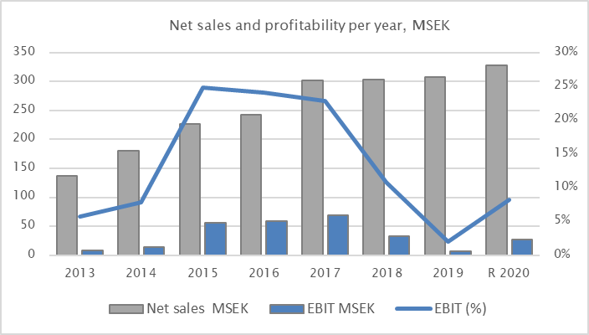

Other

Seasonal effects

MSAB is not dependent on the seasons in the sense that is normally meant by the term seasonal effects. However, the majority of the Company’s customers have a purchasing pattern that follows their budget period. Budget periods differ between countries, but most common in MSAB’s largest markets is that they follow the calendar year or end on 30 September. Historically, this has been reflected in sales in such a way that the second half of the year is stronger than the first.

Risks and uncertainty factors

Through its operations, the Group is exposed to risks and uncertainty factors. Information on risks and uncertainties other than currency exposure due to foreign subsidiaries and the fact that most invoicing in Sweden is denominated in foreign currencies can be found in more detail in the 2019 Annual Report. The Annual Report is available on the Company’s website. MSAB is monitoring developments regarding Corona virus Covid-19 and is evaluating the extent to which it can impact the Company’s operations in the short- and long-term. It is currently not possible to assess the extent of impact on operations.

Accounting principles

This report has been prepared for the Group in accordance with the Swedish Annual Accounts Act and IAS 34 Interim Financial Reporting, and for the Parent Company in accordance with the Swedish Annual Accounts Act and the Swedish Financial Reporting Board’s recommendation RFR 2 Accounting for Legal Entities. Information as per IAS 34 is provided in notes as well as in other places throughout this interim report. The accounting principles adopted for the Group and the Parent Company are consistent, unless stated below, with the accounting principles used to

prepare the most recent annual report. For short-term financial assets and liabilities, the reported value is a reasonable estimate of fair value.

The Parent Company

Net sales for the Parent Company for the period amounted to SEK 105.7 (82.3) million. EBIT for the period was SEK -2.1   
(-21.3) million. Investments for the period amounted to SEK 0.2 (1.0) million. There were 153 (138) employees in the Parent Company at the end of the period. Risks and uncertainty factors are the same for the Parent Company as for the Group.

Related party transactions

There were no related party transactions during the period other than settlement of internal transactions between the Parent Company and its subsidiaries.

Financial Calendar

28 October, 2020 Interim report January-September

27 January, 2021 Year-end report 2020

The information in this report is such that MSAB, Corporate ID number 556244-3050, is required to disclose in accordance with the EU’s Market Abuse Regulation. The information in this report was submitted for publication on 22 July, 2020 at 08:00 CEST*.*

This report and earlier financial reports and press releases are available on the Company's website: www.msab.com.

Questions should be addressed to:

Chief Executive Officer Joel Bollö  
Tel. +46 8 739 0270  
Email: joel.bollo@msab.com

Statement from the Board and CEO

The under-signed certify that this interim report provides, in accordance with current regulations, a fair and true overview of the Parent Company’s and Group’s operations, financial position and earnings, as well as describing the significant risks and uncertainty factors to which the Parent Company and the subsidiaries that comprise the Group are exposed.

Stockholm, 22 July, 2020

**Micro Systemation AB (publ)**

Corporate ID number 556244-3050

Henrik Tjernberg Joel Bollö Ann Hellenius Jan-Olof Backman  
Board Chair Chief Executive Officer Board Member Board Member

Carl Bildt Linda Nyberg Peter Gille  
Board Member Board Member Board Member

This report has not been reviewed by the Company's auditors.



















https://www.msab.com/products/